Tutorial 8: Introduction to Node.js servers
- File server.js is running on port 8080
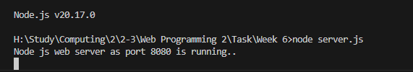
- Screen shot 2: response to the http request for case req.url == “\”

- Screen shot 3: response to the http request for case req.url == “\student”

- Screen shot 4: response to the http request for case req.url == “\admin”

- Screen shot 5: response to the http request for case req.url == “\data”. The browser will show the JSON string using JSON.stringify

- Screen shot 6: response to the http request for other case

The web server will handle all the http requests for the web application. Node.js server is a runtime environment that allows developers to run JavaScript code on the server side, outside of the browser. Node.js provides capabilities to create web server which will handle HTTP request asynchronously. The key feature of Node.js is its event-driven, non-blocking I/O model, which is ideal for handling concurrent requests and performing asynchronous tasks, such as reading or writing to databases, interacting with APIs, or serving web pages, without waiting for operations to complete before moving to the next task. Node.js operates on a single thread, unlike traditional server environments that rely on multi-threading.
HTTP built-in module in Node.js can create an HTTP server that listens to server post and response back to client by using the createServer() method. The request object gets information about the current http request (url, request header, data,…). The response object send a response for current http request. Response object uses writeHead() to set header, write() method to write a string and end() method to send response.

